# Computer Graphics (UCS505)

# Project on

# Cityscape Vision

**Submitted By**

Charul Wadhwa 102103210

Kheman Mittal 102103217

Vishnu Batra 102103223

# 3CO8

**B.E. Third Year – COE**

**Submitted To:**

**Dr. Yadwinder Singh**



**Computer Science and Engineering Department Thapar Institute of Engineering and Technology Patiala – 147001**

**TABLE OF CONTENTS**

|  |  |  |
| --- | --- | --- |
| **Sr. No.** | **Description** | **Page No.** |
| 1. | Introduction to Project | 1 |
| 2. | Working/Explanation | 1 |
| 3. | Computer Graphics concepts used | 2 |
| 4. | User Defined Functions | 3 |
| 5. | Output/ Screenshots | 4 |

**INTRODUCTION**

"Cityscape Vision" is a computer graphics project designed to immerse users in a lifelike urban environment using OpenGL. The project meticulously recreates a bustling cityscape with a highway bustling with moving cars, set against a skyline of towering skyscrapers. The focus on detail and realism aims to transport users into a digital world that feels vibrant and alive.

One of the standout features of "Cityscape Vision" is its dynamic day-night cycle. Users can seamlessly transition between different time-of-day views, each offering a unique atmosphere and ambiance. Whether it's the warmth of the sun during the Day View, the serene transition into the Evening View, or the captivating lights of the Night View, each perspective provides a distinct experience for users to explore.

Moreover, the project incorporates dynamic elements to enhance immersion. Moving clouds drift across the sky, while celestial bodies such as the sun and stars add to the visual spectacle. In the Night View, users may even spot a passing aircraft, further enriching the dynamic nature of the environment.

Hence, "Cityscape Vision" aims to captivate users with its blend of realism, interactivity, and aesthetic charm. By offering a glimpse into a digitally rendered metropolis where imagination knows no bounds, the project invites users to embark on an enchanting journey through the vibrant tapestry of urban life.

**WORKING/EXPLANATION**

Our project starts with a view of a sunny day in a city full of various buildings and cars and other vehicles moving in four lanes of a highway. For exploring the city on the other time of day given below are specific keys we have used:

* **UP Arrow -** (For switching to the morning view)
* **DOWN Arrow -** (For switching to the evening view)
* **LEFT Arrow -** (For switching to the night view)

The evening time view shows a setting sun beautifully in between the yellow-orange clouds behind the buildings. On the other hand, the night time view shows a sky full of clouds covered in a blanket of stars with a beautifully shining moon and an airplane is passing by this sky and people traveling in cars on the road are enjoying the view

**CONCEPTS USED**

In the above project we have used,

**2D and 3D transformations:-** 2D and 3D transformations are fundamental operations used to manipulate objects in a virtual environment. These transformations include translation, rotation, scaling, and shearing.   
  
**Translation:-** Translation involves moving objects on the screen or in space without altering their shape. This is achieved by adding specific values to the x, y, and z coordinates of each vertex in the object.

**Polygon drawing:-** Polygon drawing is another essential aspect, where various shapes like circles, spheres, and polygons are rendered.

**Circles:-** Circles can be constructed by iterating over angles from 0 to 360 degrees around a centre point, while spheres can be drawn using libraries like glutSolidSphere. Polygons can also be formed by connecting points in space.

**Lines:-** Lines are drawn by specifying the starting and ending points (x, y coordinates) in space. These lines serve as the building blocks for more complex shapes and structures in computer graphics.

**Polygon filling:-** Polygon filling is the process of colouring the interior of a polygon using the glColor3f function, which allows specifying RGB values for filling colours. This adds depth and realism to rendered scenes, making objects appear solid and tangible.

The above all further enhance the visual quality of computer graphics projects, creating immersive and realistic virtual worlds.

**USER-DEFINED FUNCTIONS**

* **void updateobj(int value)**: To update the position of objects by setting up speed to show their movement. This function updates the movements of vehicles and in night view also the movement of airplane.
* **void SpecialInput(int key, int x, int y)**: To switch between different views by clicking on UP*,* DOWN, LEFT keys for morning, evening and night view respectively.
* **void display()**: To draw various elements such as roads, grass, pole, tree, design of cars, buildings, glass and tower.
* **void display_day()**: To change the colors to the default color of the building's glasses, when it's daytime view.
* **void display_night()**: To change the colors of the building's glasses, when it's evening time view and night time view.
* **void display1()**: To draw the main elements of the view during day time that includes color of sky, presence of sun and position of clouds. It completes the whole view by calling display_day function to include the various other common elements.
* **void display2()**: To draw the main elements of the view during evening time that includes setting sun and clouds. It completes the whole view by calling display_night function to include the various other common elements.
* **void display3()**: To draw the main elements of the view during night time that includes color of sky, a moving plane, presence of moon and stars covering clouds. It completes the whole view by calling display_night function to include the various other common elements

**OUTPUT/ SCREENSHOTS**

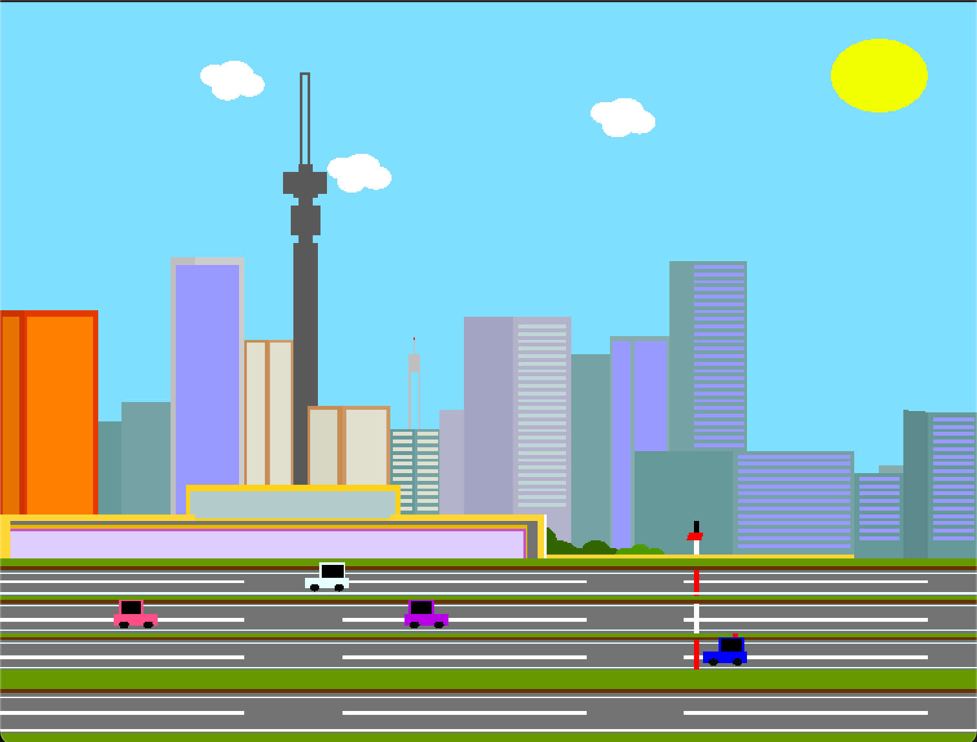

Fig 5.1 Depicts Day View

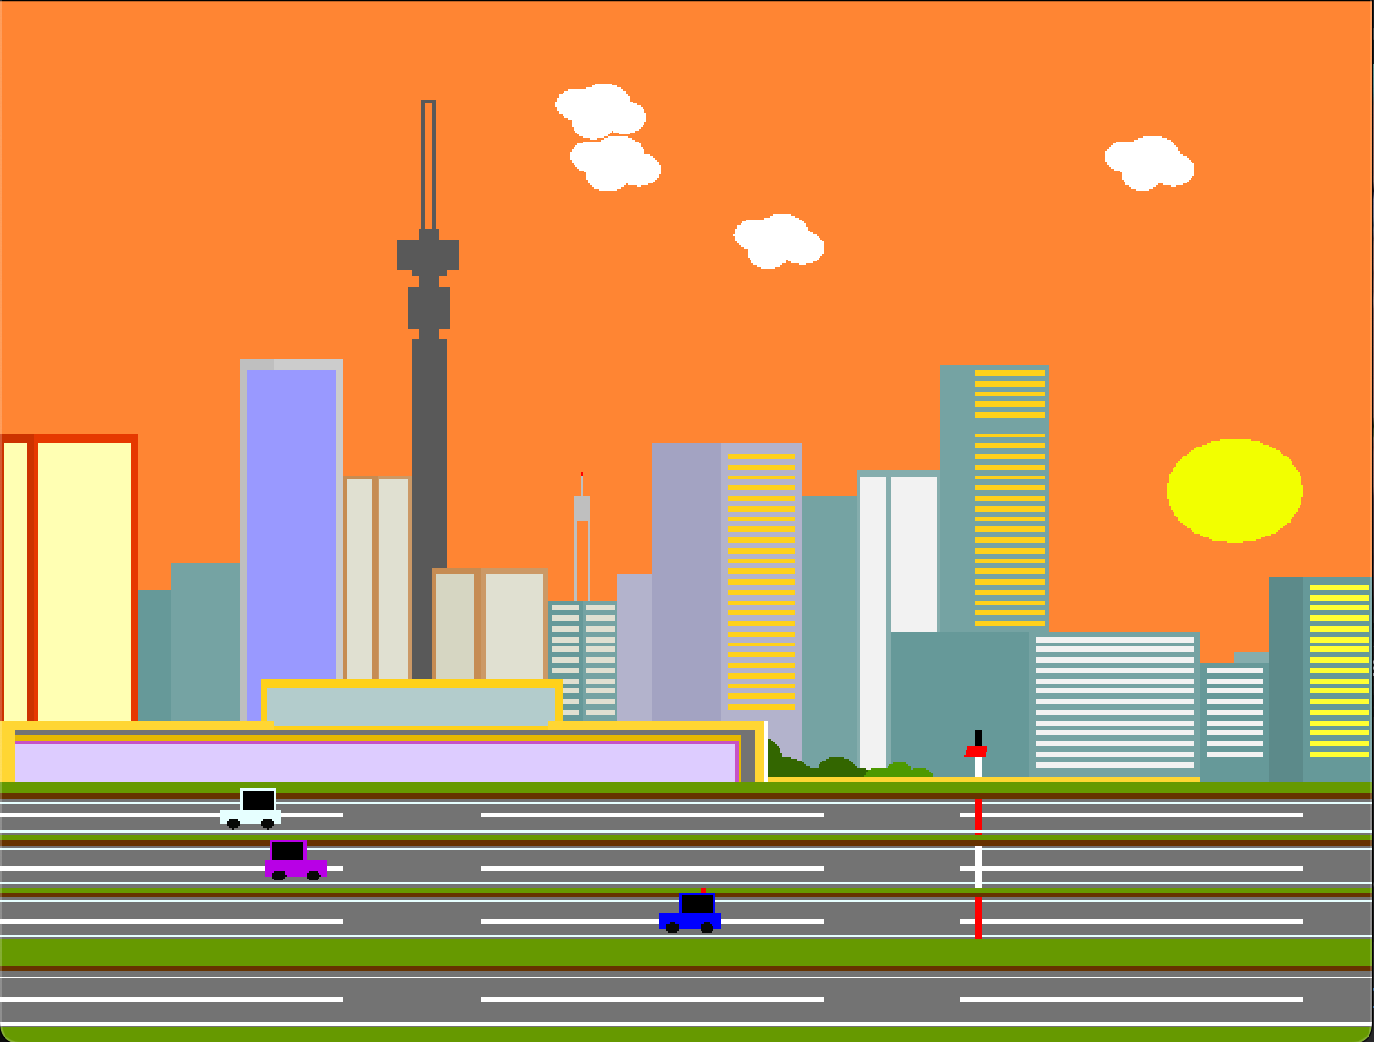

Fig 5.2 Depicts Evening View

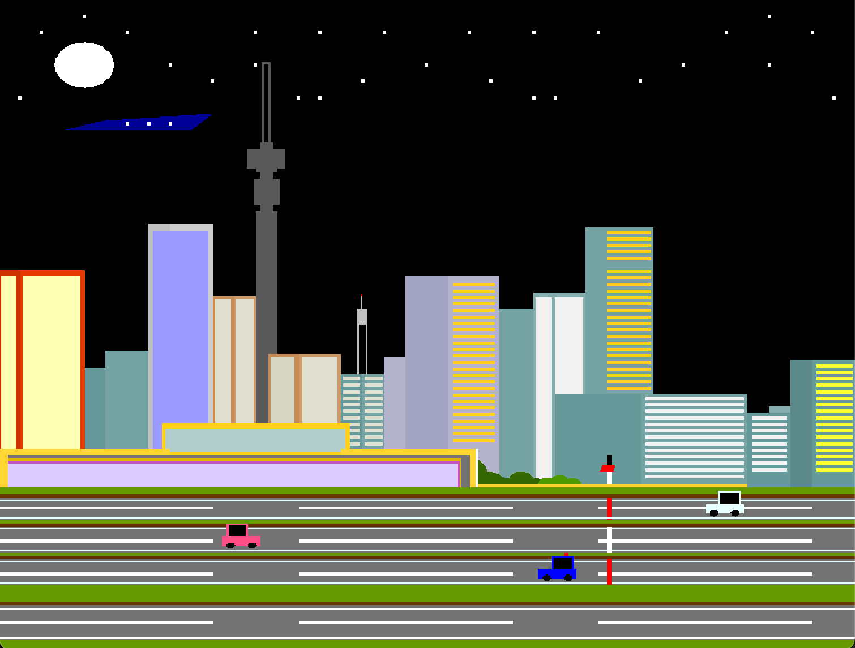

Fig 5.3 Depicts Night View

**Video Link :- <https://drive.google.com/file/d/1KE2Nmo26YwzvLkpbC4dCzvr34xRDEdas/view?usp=drive_link>**